# CS 255 System Design Document Template

This template lays out all the different sections that you need to complete for Project Two. Each section has guidance to prompt your thinking. You will need to continually reference the interview transcript as you work to make sure that you are addressing your client’s needs. There is no required length for the final document. Instead the goal is to complete each section based on what your client’s needs are. Remove this note when you are finished, and replace all bracketed text with the relevant information.

## UML Diagrams

### UML Use Case Diagram

### UML Activity Diagrams

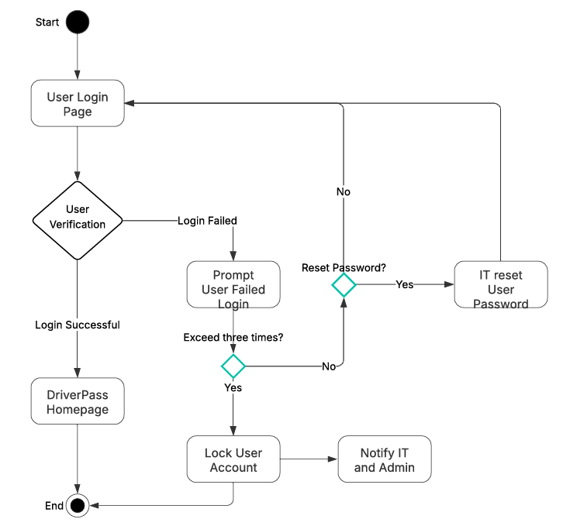

### UML Sequence Diagram

### UML Class Diagram

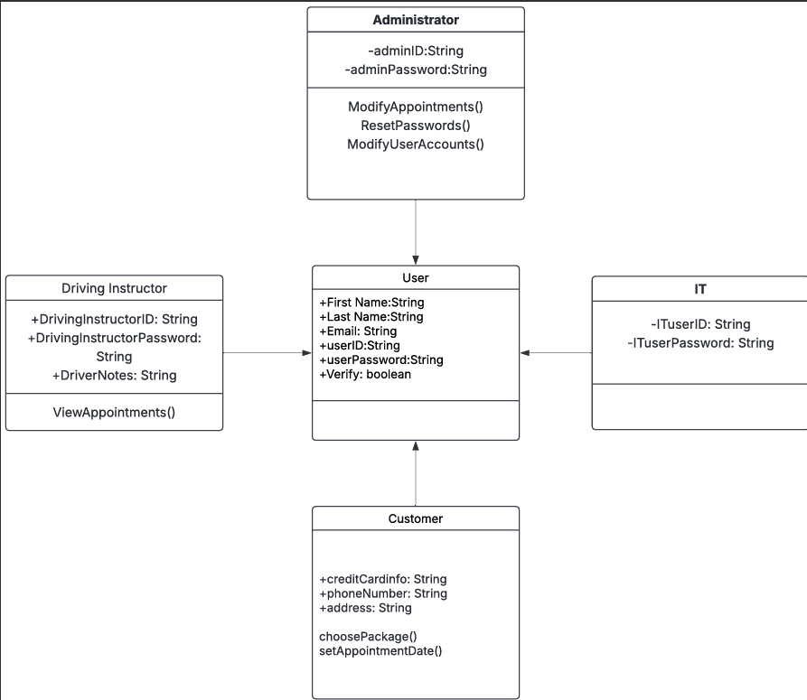

## Technical Requirements

*[Based on the diagrams you have created, describe the technical requirements of your system. These requirements should address the required hardware, software, tools, and infrastructure necessary for your system design.]*

Some technical requirements that are needed for this system are:

* Computers or mobile devices need access to the website.
* Routers and Firewalls that connect and secure the clients and users on the website.
* Website must have sufficient processing power, storage, and memory to handle user functions and requests.
* Must be proficient in using multiple programming languages for the web development and maintenance of the system.
* A database management system like MySQL to manage and store user data, training progress, and other system data.
* Integrating payment gateways for handling customer transactions between the system and users.
* Multi-factor Authentication to verify users when accessing the system.
* An up-to-date Security software that regularly keeps updating to most recent version to protect our users and system’s database from malicious attacks.